Essential 3D printing Topics
Explore the topics below for an indepth overivew of all the parts and theories that go into building a 3D Printer.
- Linear Rails
- Linear Rods
- Linear Carriages
- Transmission
- Stepper motor
- Extruder
- Print Bed
- Limit Switches
- Motherboards
- Stepper Drivers
- Microstepping
- Power Supply
- Wiring
- Firmwares
- Slicers
- Calibration
- Dual Extrusion
- Filament
- FAQs
The images is below

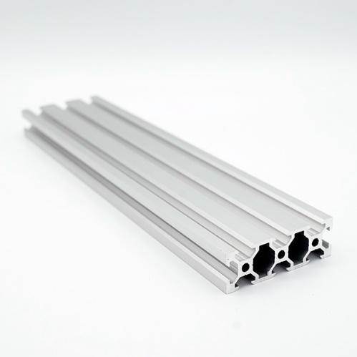
Linear Rails
Precise linear motion is required for 3D printing. Linear rails act as a guides for motion carriages and in some cases, play a dual role as the frame for the 3D printer.
When designing a linear motion system for a 3D printer, you have two choices for the guides that the components will ride on. The first choice is a rail. Similar to railroad tracks, a carriage rides on top of the rail which is typically supported from underneath. The carriage can only move in the direction that the rail is pointing. The second choice is a cylindrical guide known as a linear rod. Linear rods will be discussed in their own dedicated section, so we will focus on linear rails here.

Tranditional Linear Rail
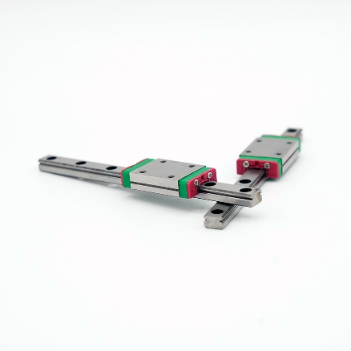
A “traditional” linear rail is a thin and long rectangular piece of steel with two dovetails that run along either sides. Hardened or stainless steels are the materials of choice because even rails with small cross-sectional areas resist flexing. Further, steel is relatively easy to machine, so tight tolerances are possible. In linear motion, tight tolerances usually refers to how straight the rail is. It should go without saying that any bend or flex in the rail would affect print quality. The dovetails cut into the length of the rail are where the ball bearings of the carriage ride. Properly lubricated rails will perform smoothly for a long time. The two drawbacks of using “traditional” linear rail in a 3D printer build are the price and the need for a physical frame to attach the rails to. Quality rails and their matching ball bearing carriages from a reputable company like McMaster-Carr will usually cost an arm and a leg. For this reason, many DIYers tend to purchase import rails with questionable quality control. Once you have your hands on enough linear rail for each axis you will have to create a frame to attach the rail to. Typically, the frame is constructed out of aluminum extrusion. But why can’t the aluminum extrusion act as the rail?
Figure 1: "Tranditional" Linear Rail

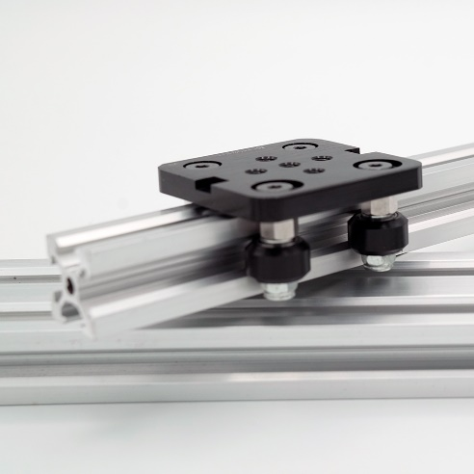
Aluminum Extrusion Rail
Figure 2 : Aluminum Extrusion Rail
The answer to that last question is that aluminum extrusion can in fact act as linear rail. There are a couple of different types of aluminum extrusions that are suitable for linear motion. Most of these extrusions have some sort of V-geometry that creates a track for wheels to move on. This V-geometry is also the namesake for this class of aluminum extrusion, which is known as V-rail. The ability for the V-rail to act as both the linear axes for the 3D printer as well as the frame may sound too good to be true, but trust me, I have had a lot of success with these linear rails. However, there are a couple drawback to be aware of. Aluminum is not as stiff as steel, so for large format printers the V-rails need to be supported throughout the run. The perfect case would be to have steel V-rails, but it is difficult to extrude steels through complex profiles and machining the steel into V-rail would be too expensive. The other drawback of aluminum extrusion is that the delrin wheels that ride on the rail will have a shorter lifespan than the ball bearings that ride on the “traditional” rails. Even with these shortcomings, V-rail is a great system for building a 3D printer around.
For aluminum Extrusion rail there are V-rail which is linear rial and not linear rail in the image below.
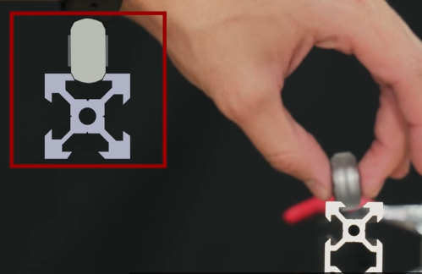
V-rail is matches the contour of a chamfered wheel.
Figure 3: Vrial and chamfered wheel
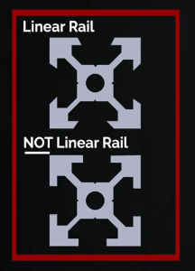
The four profiles of 3D printer and CNC machine most uses are:
Figure 4: Linear rial and NOT-linear rail
20x20 | 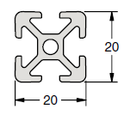
20x40 | 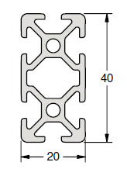
20x60 | 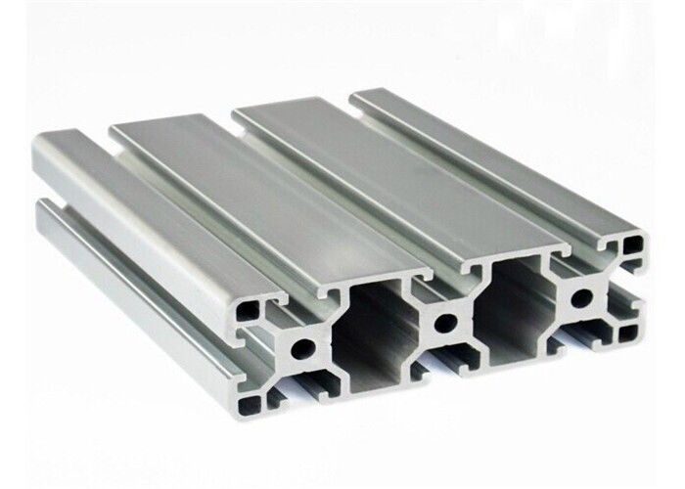
40x40 | 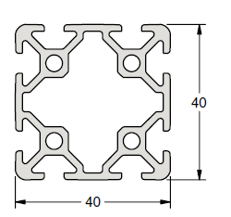
C-Beam | 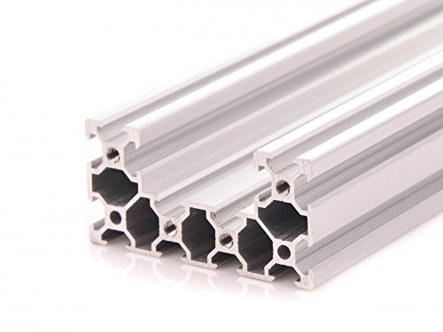

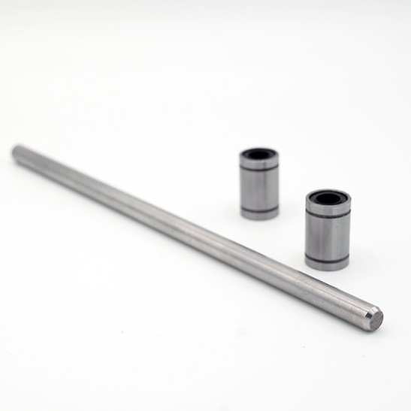
Linear Rods
Cylindrical guides are affordable alternatives to linear rails. Bearings slide along the rods to provide free motion in the direction of the rod.
The alternative to using rails for linear motion is linear rods. Linear rod comes in a variety of different lengths and diameters, but typically rod with a diameter of 8mm is used in 3D printer builds. Commonly made from steel and chrome plated for enhanced hardness, linear rod is less expensive to manufacture. The simplicity of rod translates to less tolerance issues compared to linear rails, especially when purchasing cheap imported linear motion systems. Linear ball bearings (also known as ball bushings) ride on the linear rod to provide the actual motion. These bushings are also widely available and cost significantly less than the carriages that ride on linear rails.

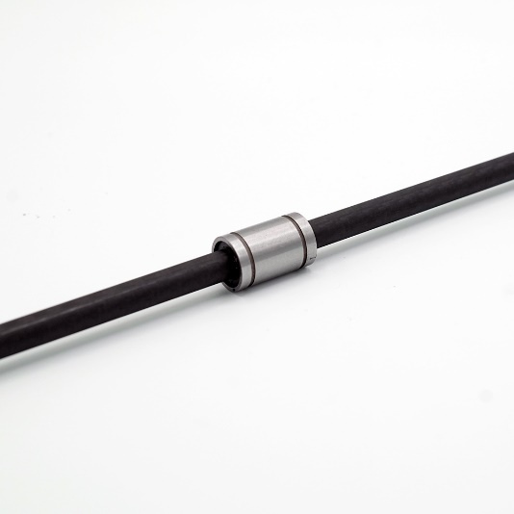
A new Linear Rod Material
Figure 5: Carbon Fiber rod with a Linear Bearing/ Busing
Interestingly, carbon fiber has emerged as a new material for linear rods. Weight for weight, carbon fiber is stiffer then both aluminum and steel. Therefore, hollow carbon fiber rods are extremely light while still being sufficiently stiff for linear motion. Carbon fibers are new to the market and the ones with acceptable tolerances for 3D printers cost a pretty penny. Cheap carbon fiber rods that can be found on amazon have an inconsistent outer diameter along the length of the rod, requiring sanding to achieve smooth motion of the bearing. Please note: carbon fiber dust generated from cutting or sanding is easily inhaled and very toxic. 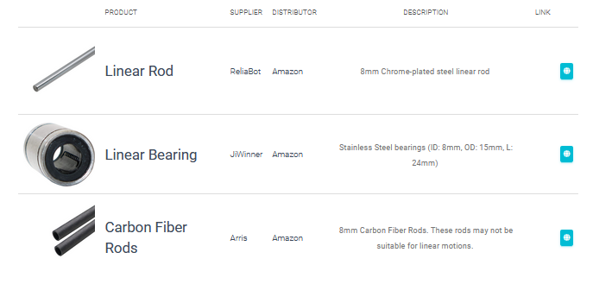

Linear Carriages

Transmission

Stepper motor

Extruder

Print Bed

Limit Switches

Motherboards

Stepper Drivers

Microstepping

Power Supply

Wiring

Firmwares

Slicers

Calibration

Dual Extrusion

Filament

FAQs

